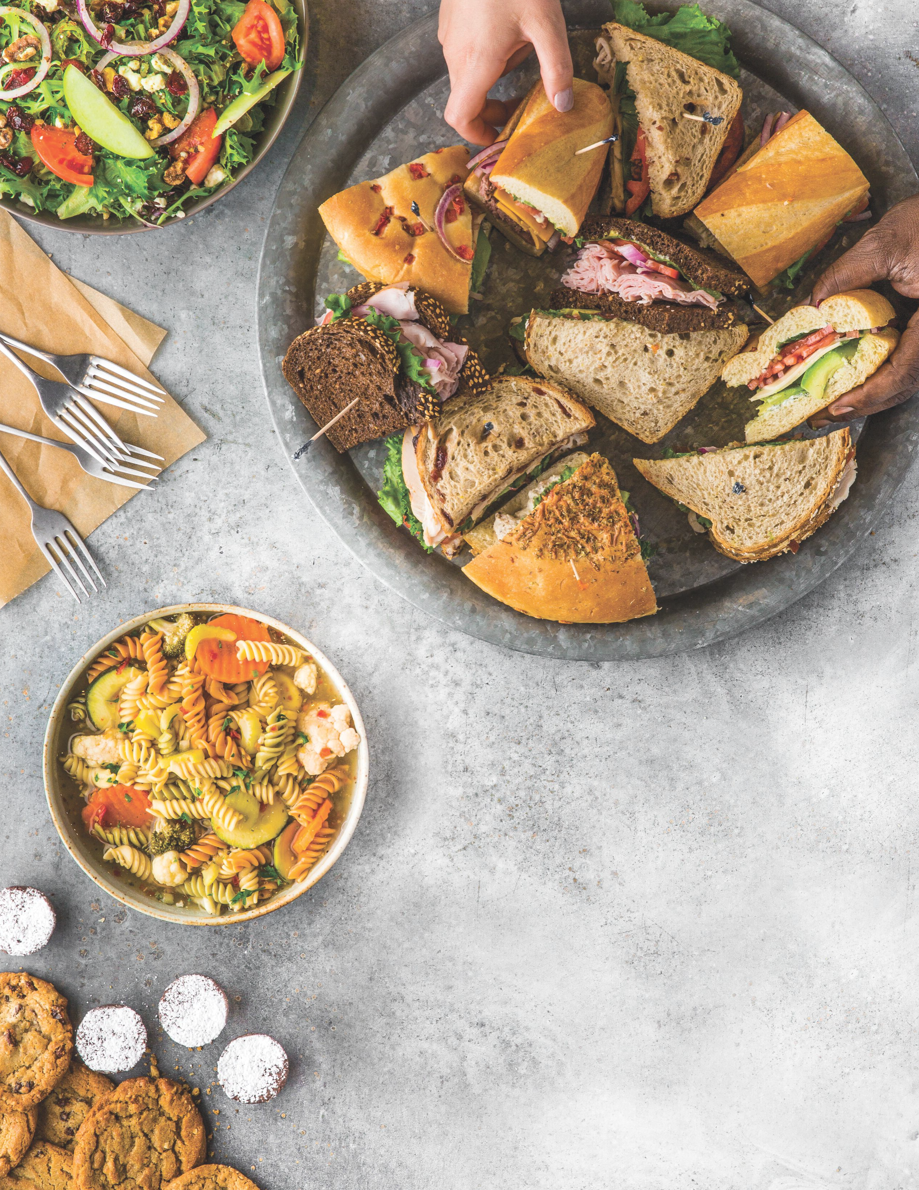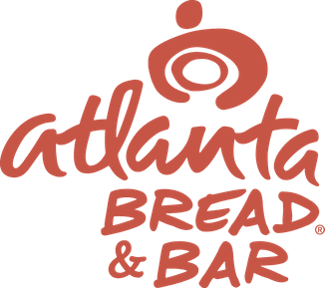

LET US CATER
There’s no wrong occasion for Atlanta Bread. Order our famous menu as platters or boxed lunches next time you need to feed a crowd well.
ENJOY $25 OFF
A CATERING ORDER OF $150 OR MORE

41 0 Peachtree Parkway Ste 1 1 6
Cumming, GA 30041
( 678 ) 845 - 5881
atlbreadcollections@ gmail. com
Must contact store directly, not valid for online orders.

